Parent Consent and Healthcare Provider Authorization For Management of Type 1 Diabetes at School and School Sponsored Events

Student Name: _____________ DOB: _______________
School: ___________ Gr: _________________
Healthcare Provider’s opinion on Student’s Independence Level
FULL ASSISTANCE: Requires trained staff to assist child with blood glucose checks, prep, calculations, low treatments and administration of insulin when needed. Requires adult verification of carbs consumed equals carbs covered by insulin dose.
Due to ________’s young age, she is not aware of her low blood sugars and needs close adult observation. ____________ requires a trained diabetes personnel to be near her at all times to respond to signs/symptoms of low BG, to all pump and sensor alarms, and treat a low blood glucose quickly.
Parents CAN remotely provide information as needed on carbohydrate counting and dosing through written instruction, message or call.
Student should NOT miss class/peer time for usual diabetes care.
Continuous Glucose Monitor (CGM): Dexcom
☒ May use CGM value in lieu of finger stick to make treatment decisions (dose insulin/treat low blood sugar)
☒ If CGM display is under 100 mg/dL with down arrow(s), treat as hypoglycemic event.
☒ Check CGM display with alerts and per below orders.

Check Blood Glucose (BG) Levels (on CGM when used or meter when not)
- Always before eating
- For suspected hypoglycemia
- For suspected hyperglycemia
- For suspected illness
- When nurse or parent requests an additional check
- (Meter only) When the sensor reading is not consistent with current symptoms (if any present)

Target Blood Glucose
Optimal control is 80-140 mg/dL but action is only required at school as specified in this document.

1. Hypoglycemia/LOW BG, BG or CGM under 70 mg/dL or CGM is less than 100 with down arrow(s)

*Treating a low BG: __________ must have her blood glucose meter and fast acting carbs to treat a low blood glucose near or on her at all times, especially at recess and PE.

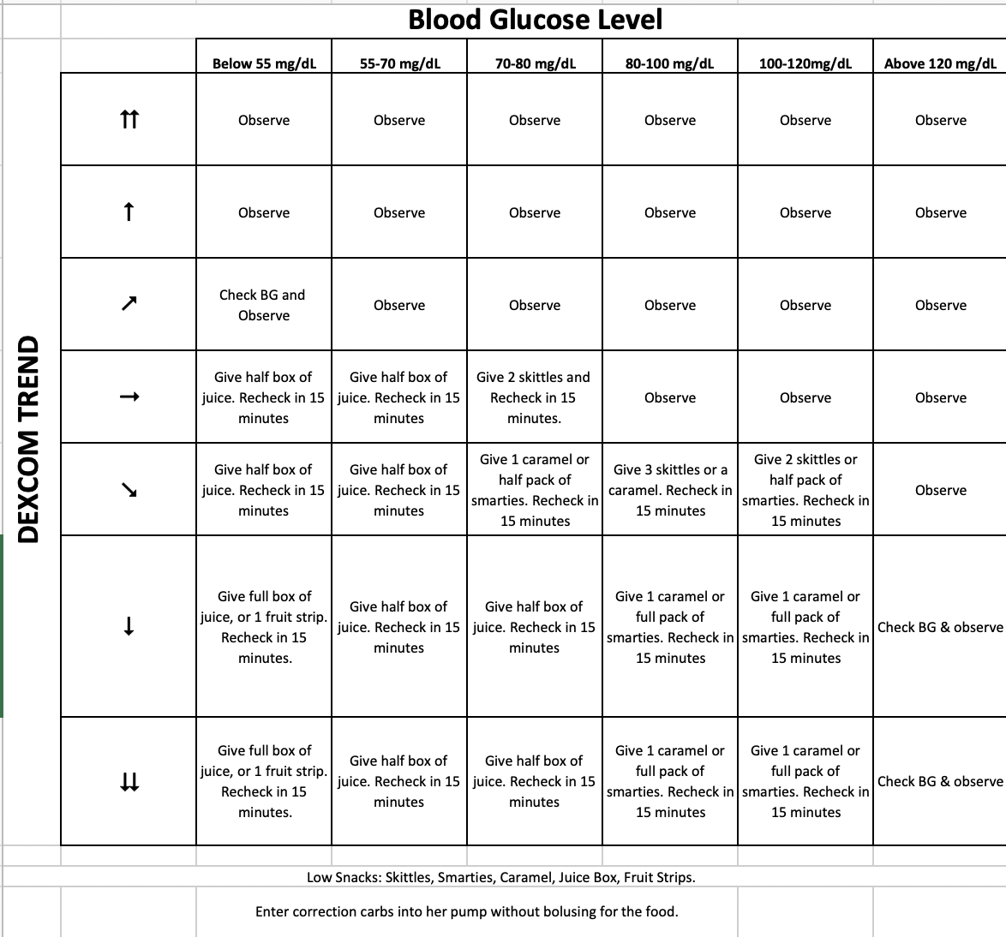

Managing severe hypoglycemia (unconscious, unresponsive, seizure, combative or unable to swallow):

Administer:
☒ Glucagon 0.5 mg intramuscular/subcutaneous injection x 1 & call 911 (For children weighing less than 44 lbs (20 kg) and under 6 years old)

Potential adverse reaction: nausea/vomiting

2. Hyperglycemia/High BG, BG over 180 mg/dL (see flow chart):
☒ If no Insulin has been given in the last 2 hours, give a correction per correction scale.
☒ If BG/CGM still > 250 and student has symptoms of ketosis: headache, nausea, stomachache, vomiting: call parents.
☒ Pump/CGM high alarm is set for 180. If high alarm rings, enter BG into pump and bolus per pump suggestion.
☒ Recheck BG/CGM in two hours and if BG/CGM > 180, enter BG into pump and bolus per pump suggestion again.

3. Diet: Carbohydrate (Carb) Counting
☒ Nutrition facts for school food must be available daily to student; parent to label home foods
☒ Student requires Fiasp insulin for all carbs consumed unless treating/preventing hypoglycemia
☒ Insulin dose for carbs must match carbs actually consumed [verify if unreliable eater or per orders (see #7)].

4. Exercise:
☒ Carbs to be available during exercise; check BG/CGM as needed & provide snack as needed before exercise:
"As needed" before exercise means parent & school nurse will discuss different activities (ex: recess vs PE) & adjust carb snack based on glucose response to each activity. Guardian/school nurse discuss plan before school start.

You can use our exercise guide below:
☒ 5 carbs without insulin for every 15-30 min of moderate exercise
☒ More carbs may be needed for longer or more intense exercise (ex: run or swim)
☒ Less carbs may be needed for exercise less intense/less aerobic
Do not exercise if: not feeling well, ketones present, BG under 80 mg/dL

5. Special Circumstances:
Parties/Snacks:
Give insulin for all carbs, regardless of last/next shot time (BG check not required)
If BG is 60-70 mg/dL just before lunch, option to: Treat with fast acting carbs per their age & escort to lunch. Start to eat lunch then recheck BG. Once recheck is 70 mg/dL, give meal insulin.
If BG 70-100 at any time, and student "feels low": If it's lunch, move insulin dose for lunch until after BG starts to come back up. If not meal time but student feels symptoms of low BG, option to give 5 carbs, & recheck BG in 30 min.

6. Insulin at School
☒ Name of Insulin: Fiasp via Omnipod insulin pump
☒ Insulin to be given 0-15 minutes before all carbs (including lunch) unless carbs are being used to treat/prevent hypoglycemia.
☒ Food Bolus: Follow settings pre-programmed into the pump which may be changed over time and can be modified by the pump’s algorithm. The current settings are insulin to carb ratio 1 unit of insulin for every 10 grams of carbohydrate.
☒ Correction Bolus before meals (by calculation): Follow settings pre-programmed into the pump which can be changed over time and can be modified by the pump’s algorithm. The current settings are 1 unit insulin for every 180 mg/dL over 140 mg/dL.
☒ Must have back-up syringe or insulin pen at school in case of insulin pump failure. If infusion set falls off or pump is malfunctioning: call parent and cover elevated BGs with syringe injection of Fiasp insulin per ratios below rather than via insulin pump (check with parents first).

Carbohydrate ratio:
Breakfast: 1 unit insulin per 5 grams of carbs
Snack: 1 unit insulin per 10 grams of carbs
Lunch: 1 unit insulin per 10 grams of carbs
High blood glucose correction factor: 1 unit of insulin lowers BG 180 mg/dL, 1/2 unit lowers BG 90 mg/dL Target BG for calculations: 120 mg/dl

Adjustment of Insulin Dose: Parents authorization to Adjust Insulin
☒ +/- 30% current dose and/or carb ratio
☒ Always contact guardian for dosing clarifications
☒ If the dose reported by guardian is less insulin than the most recent orders, ALWAYS use the lower dose even if provided by guardian (vs MD orders) to prevent risk of severe hypoglycemia. This is especially important within the first few months of starting school. Call parents to clarify.

If pump Fails and no bolus/shot of Fiasp in last 3 hours

1 unit to drop her 180 points
1/2 unit to drop her 90 points
Daytime target = 120

Correction Factor: 1/2 unit to drop |  | 90
Target Blood Sugar: |  | 120
Blood Glucose Range before meal without insulin infusion in the past 3 hours: |  |  | Extra Fiasp insulin needed prior to meal to lower blood sugar to target:
Less than |  | 209 | 0 | units
210 | - | 299 | 0.5 | unit
300 | - | 389 | 1 | units
390 | - | 479 | 1.5 | units
480 | - | 569 | 2 | units
570 | - | HI | 2.5 | units

7. Disaster Plan:
☒ It is advisable to prioritize this student to be among the first students evacuated from the campus during a disaster. Goals during a disaster: prevent a severe low BG from too much insulin & prevent diabetic ketoacidosis caused by lack of insulin
☒ It is imperative and life sustaining during a disaster for this student to continue insulin pump treatment with Fiasp insulin at the programmed basal rates and bolus settings for food and blood glucose measurements.

8. Test Taking
Please follow standard accommodations for tests taken by students on insulin treatment. They can experience cognitive difficulties when blood glucose is below 70 mg/dL or above 300 mg/dL. They need to be allowed to test their blood glucose and/or look at their cell phone to review the readout of their CGM if they suspect hyper or hypoglycemia. If it is confirmed, they need to be treated appropriately for the above and it may take up to 30 minutes for their normal cognitive skills to return. Therefore, they would also need extra time, without penalty, to complete the examination when this problem occurs.

Parent/Guardian Authorization: I, the undersigned, request that this DMMP plan be administered to my child in accordance with Education Code Section 49423. My signature below provides authorization for the above written orders. I understand that specialized physical health care services may be performed by unlicensed designated school personnel under the training and supervision provided by the school nurse. I will provide all necessary equipment/food/meds discussed above & will notify school staff if there is a change in health status, medical team, orders, or insulin dose.

Signature:________________________________ Date: ________________

Authorizations and Release of Information:
The signatures below provide authorization for the above written orders, including administration of insulin and glucagon if ordered, and show agreement that all ordered procedures will be implemented in accordance with state and federal laws and regulations. This form also provides authorization to transfer medical information between the school and the physician relating to care of diabetes at school and related health issues. Health care services ordered above may be performed by unlicensed designated school personnel under the training and supervision provided by the school nurse as legally permitted. The parent is responsible to provide the necessary supplies and equipment. This authorization is for a maximum of one year. A final copy of this authorization must be provided to all parties. If changes are indicated, a new written authorization for the changes (may be faxed) as an addendum or a new form.

Health Care Providers:

PROVIDER SIGNATURE : ____________________________________

Diabetes Team:

